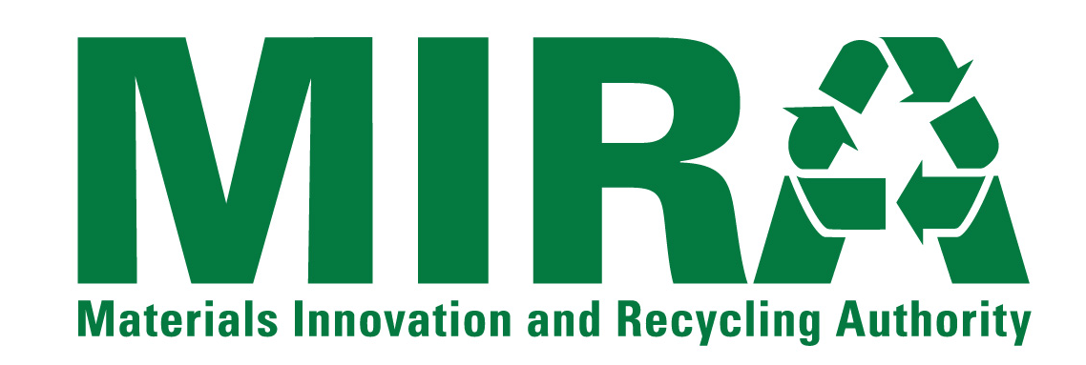
VEHICLE SAFETY STANDARDS COMPLIANCE FORM
Bidders for the on-call transportation and disposal work of municipal solid waste diverted from MIRA’s CSWS MSW Facilities are required to be in compliance with and not limited to the following Federal Motor Carrier Safety Administration and State of Connecticut D.O.T. vehicle safety requirements.
This section must be fully completed and a NO answer should be addressed in writing and attached to this Form in the Bidder’s Bid.
 |  | Yes | No
1. | Bidder’s drivers or their sub-contracted drivers have a CDL or are licensed to drive both in and out of the State of Connecticut.
2. | Bidder(s) has record on file of driver's vehicle driving record.
3. | Bidder(s) has records of vehicles being used regarding transport weight capacity and compliance with Federal and Connecticut DOT safety guidelines.
4. | Bidder(s) has vehicle maintenance procedures/schedules for both its and its sub-contractor vehicles.
5. | Bidder(s) has safety procedures for its and its sub-contractor vehicles regarding Hand-Operated Controls, Foot Operated Controls, and Dash Board Displays as outlined in both the Federal and Connecticut State Safety Standards.

By (Signature):
Name (Print):
Bidder Name:

